Computing Coursework 2 – Solving engineering problems with a programming language
Name: Kareena Kang
Student ID: 20790741

Add the relevant parts to the various sections below. Once complete, add this document to the .git repository and submit it together with your code, text files and functions.

Task 1 – read temperature data, plot, and write to a log file
- Include a photograph of the implementation here.
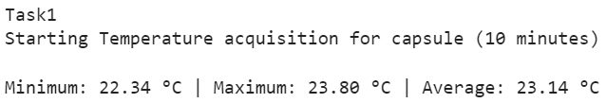
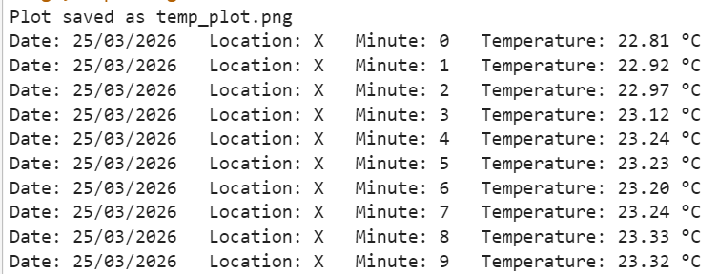
- Include the plot as an image here.
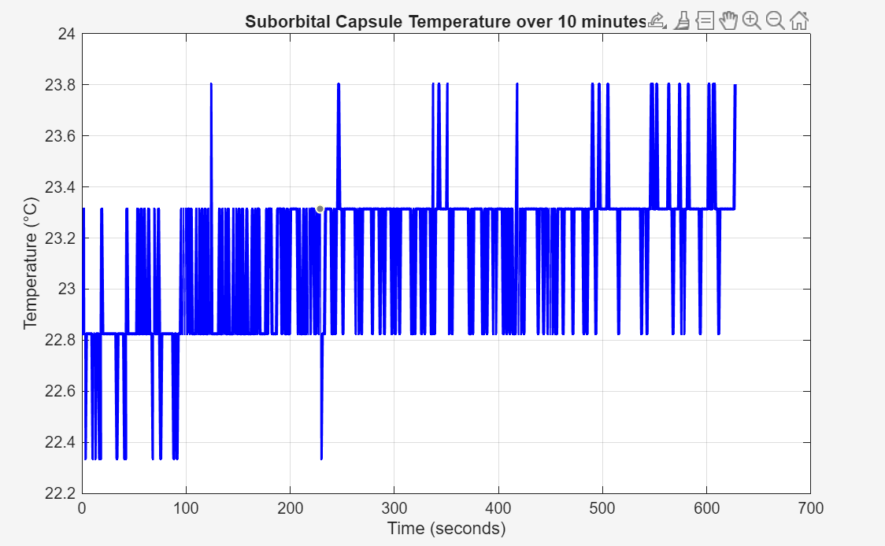

TASK 2 – LED temperature monitoring device implementation
- Include a photograph of the implementation here.
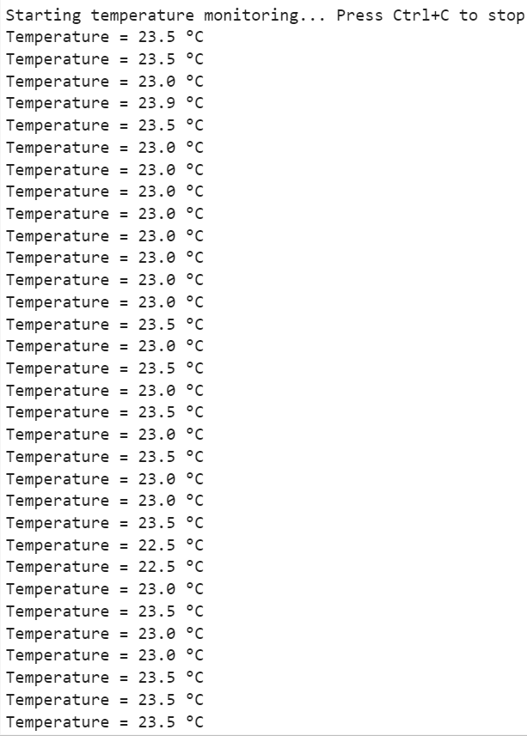
- Include your initial flowchart here.
- Include the plot as an image here.
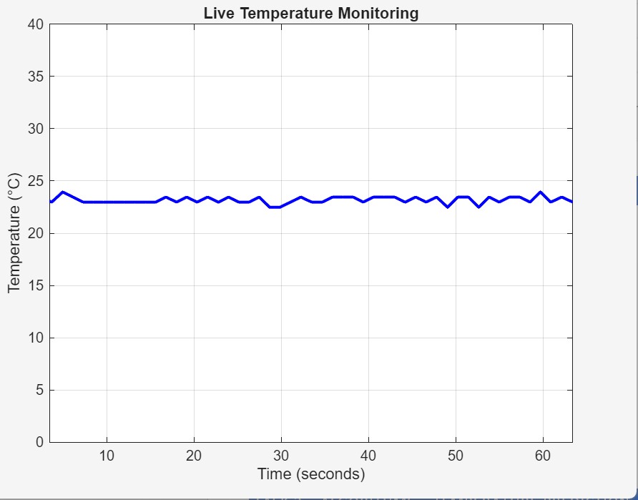
- Include your final flowchart here.

TASK 3 – ALGORITHMS – TEMPERATURE PREDICTION
- Include your initial flowchart here.

Task 4 – reflective statement
- This coursework has been an immensely challenging process as I was required to write matlab functions to a degree of complexity I have never had to consider beforehand. The flowcharts for task 2 and task 3 were a big help with the structure of the code and understanding what exactly the question is asking me to do. Actually writing the functions themselves was very difficult as I had to do research as to what matlab operations i could use to execute specific processes – for example the tic and toc operations helped me with clock counting int he temp_monitor scrip. The circuitry for task 2 took me a long time to understand as my program would have no flagged errors but the LEDs still wouldn’t light up at first. - I later found out it was because I didn't properly connect the resistor with the LEDs and the gnd. With the live graph for task 2 – the thermistor was correctly feeding the temperature readings into the program and printing them but the graph would stay stagnant – I later found out it was an issue with the figure;... section of my code which defines the graph – I have never used this function before so it was confusing at first. Smoothing out the noise spikes from the thermistor took several attempts because i had trouble with replacing the placehlder temp reading line with my actual code from task 2 that used the readVoltage function on the correct analog pin. Aside from my copious challenges, my implementation runs continually from my main script which calls functions defined in my task separated scrips. Although my calculations are basic and inaccurate as they only account for small amounts of data items at a time. In the future, I would use a larger buffer for making predictions to create a more accurate projection and better smoothing. My graphs were both very erratic because of the data variations not being averaged with a wide enough scope. Overall, this coursework has greatly expanded my confidence with using matlab and github as if forced me into deep research on the code.

